Full Paper Title in Title Case (Font: Arial 18 bold)

First Author^{*a}, Second Author^{b}, Third Authorª

ªFirst affiliation, Country
^{b}Second affiliation, Country
(use Arial 8 typeface for author’s Affiliation)

ABSTRACT
This file provides a template for writing papers for the conference. The conference proceedings will be published in an electronic format. The full paper file shall be written in compliance with these instructions. The author is asked to submit the paper in MS-Word. The files shall be saved with the full first author name as name of the file.
An abstract not exceeding 300 words, in English or Bahasa Melayu, should appear on the top of the first page, after the title of the paper in chapter titled "Abstract" (without chapter number), after the names of the authors and the contact information of the corresponding author.

Key Words: Maximum 4 Key words.

1. INTRODUCTION
It is expected that authors will submit carefully written and proofread material. Spelling and grammatical errors, as well as language usage problems, are not acceptable in the final submission. Papers should clearly describe the background of the subject, the authors work, including the methods used, and concluding discussion on the importance of the work. Papers are to be prepared in English (British) or Bahasa Melayu. Technical terms should be explained. Acronyms should be written out at their first appearance.

2. SUBMITTING THE Paper
The Full paper has to be submitted electronically by e-mail to the following addresses: http://www.pmm.edu.my/ncietvet2018/index.php. And it should be submitted by 26 May 2018.

3. PAPER FORMAT
Please note the following details: this template is an A4 format. All text paragraphs should be single spaced, with first line intended by 10 mm (0.4 inch). Double spacing should only be used before and after headings and subheadings as shown in this example. Position and style of headings and subheadings should follow this example. No spaces should be placed between paragraphs. Please do not change any of the above mentioned page, paragraph and font settings.

3.1 Fonts
Papers should use 11-point Arial font. The styles available are bold, italic and underlined.
It is recommended that text in figures is not smaller than 10-point font size.

3.2 Tables and Figures
Figure captions and table headings should be sufficient to explain the figure or table without needing to refer to the text. Figures and tables not cited in the text should not be presented. Styles Heading Table and Caption Figure are available in this template for tables and figures. The following is the example for Table 1.
Table 1 Title of Example Table
Standard Error | 20 Story |  |  |  | 30 Story
 | Uniform | ELF | SRSS | 3 Modes | Uniform | ELF | SRSS | 3 Modes
Displacement | 29.53 | 44.58 | 41.05 | 23.81 | 27.4 | 43.6 | 40.87 | 20.65
Drift | 60.4 | 60.92 | 60.47 | 38.24 | 60.91 | 63.83 | 63.53 | 26.19

Tables and figures should be placed close after their first reference in the text. All figures and tables should be numbered with Arabic numerals. Table headings should be above the tables. Figure captions should be centred below the figures. Minimum figures’ resolution: 150dpi.

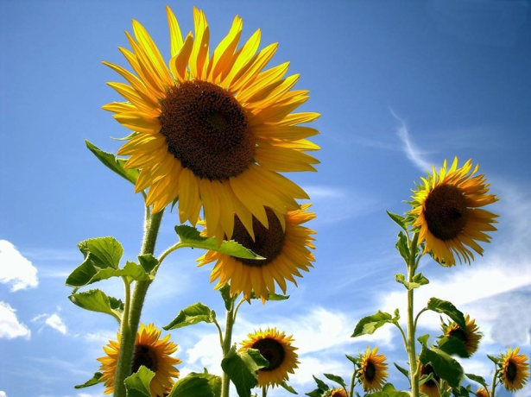
Figure 1: 30 Floor Building’s Drift Ratios Percent

3.3 Equations
Use common fonts like in your math equations. A math reference in a paragraph sentence is not numbered. The steps of a mathematical argument can be numbered using a right-aligned tab for clarity, for example
α = (1)
and
ρ=. (2)

Page Limit
The number of page for the manuscript may vary from minimum of 4 pages to the maximum of 10 pages in A4 size paper. Authors are required to strictly advise to adhere to this limit. Manuscript in excess of 10 pages may be unable to be included in the proceeding.

REFERENCES
List of references must follow A.P.A. style.
For more information, please visit: http://www.pmm.edu.my/ncietvet2018/index.php

